Q’wemtsin health society | Year End Report  2017-2018

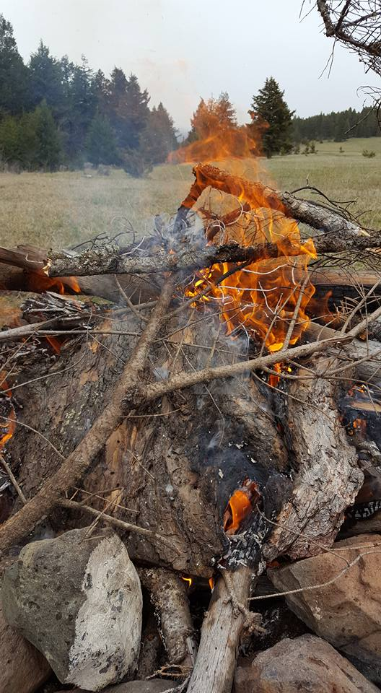
Table of Contents

Executive Summary Report …………………………………………..…3

Home and Community Care Department
Home and Community Care Report …………………………………6
Home Care Nurses …………………………………………………………..7
Health Care Assistants ……………………………………………………..8
Faces of Health Care Assistants………………..…………………..….9
Tub Program …………………………………………………………….......10
Medic Aid …………………………………………….……………..……..….10
Ensure …………………………………………………………….………….….10
SAIL Home Activity Program …………………………………………..10
Wound Management……………………………………………………..10
Diabetes …………………………………………………………………….…..11
Chronic Disease Management ………………………….…….……..11
Foot Care Report ………………………………………………..….….…..13

QHS Dental Clinic
Dental Report ………………………………………………………….……..16
Dental Services Available at QHS ………………………………….…17
Children’s Oral Health Initiative (COHI) …………………………..18
Dental Sealants in Community ………………………………………..19
Dr. Ciriani out in Community …………………………………………..20
COHI Stats …………………………………………………………………….…21

Community Health Nurses
School Health/ Harm Reduction ……………..……………………...22
TIB/WP ………..……………………………………………………………..….23
Skeetchestn Health Clinic………………………………………………..28

Primary Health Care Services………………………………………..…32
Naturopathic Services…………………………………………………..…34
Massage Therapy ………………………………………………………..….34
Mental Health Clinician ………………………………………………..…35
Flow Through Funding – Skeetchestn………..……………….…..36
Flow Through Funding - Tk̓emlúps te Secwepemc……….….38
Flow Through Funding – Whispering Pines/Clinton ………..40

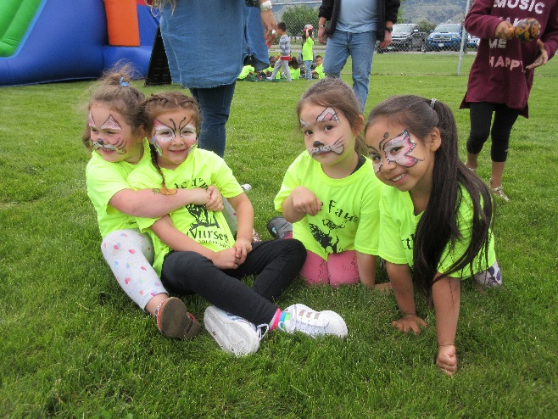
Who We Are….

We are an assembly of health care professionals who believe in providing holistic health services to our Secwepemc communities who are the Skeetchestn, Tk’emlups te Secwepemc and Whispering Pines /Clinton Indian bands.

The Q’wemtsín Health Society provides services to these communities with programs such as: Home and Community Care, Circle of Life (pre/post natal), Communicable Disease Control, Dental Care and COHI and Mental Wellness.

The goals that have been adopted by the Society are:
1. To Build Partnerships and Collaborate
2. To Deliver Programs and Services Addressing Community Needs
3. To Provide a Trusting, Open, and Professional Environment
4. To Create Opportunities for Learning
5. To Evaluate Effectiveness

Our vision statement is: Healthy Secwepemc Individuals, families, and communities

our mission is: q’wemtsin health society advances holistic health by providing programs, services and education

Executive Summary
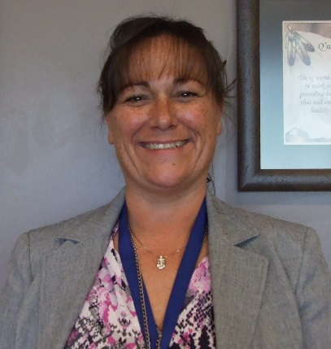

Weytk, I am excited to report we have had yet another busy and successful year at Q’wemtsín Health Society (QHS). The main endeavor for the 2017/18 fiscal year was to develop a new community health plan.
The planning process included strong involvement by members of the three communities, the QHS staff and the Board of Directors.

The nine-month process featured:
1. 3 sets of facilitated dialogue sessions and meetings with the QHS Board and with staff;
2. 258 community survey responses, and 4 community focus groups;
3. 3 discussion circles at a “World Café” style workshop of elders and community staff;
4. 2 facilitated sessions with an Elders Advisory Team.
A total of 258 people completed community surveys, providing feedback on QHS services and the draft Strategic Plan. The planning team collected surveys at the two health clinics, at band offices, door-to-door, at community events, and as part of facilitated sessions.
Facilitated sessions with community members included:
* 45+ members participated in 4 focus groups, during a community dinner event at Skeetchestn;
* 40+ elders and staff from all three communities participated in a half-day workshop with three World Café style discussion circles at Tk’emlúps te Secwépemc;
* 2 gatherings of the Elders Advisory Team, with 6 participants in each.
Discussion in the focus groups and World Café circles revealed high levels of satisfaction with existing health and wellness services. Asked what they appreciate about the healthcare services provided by QHS and the Bands, some of the most common themes in the comments were:
* Friendly, warm environment – for example, one participant said “QHS is fantastic about making people feel welcome”;
* Trusting relationships – for example, one spoke of “the relationships with the staff and community members, and the trust everyone has”;
* Provision of services in the community and in the home – convenient and accessible;
* The wide range and quality of services offered;
* Community events, such as health fairs and baby welcome gatherings.
Asked if they had any suggestions to improve QHS programs, 93 survey participants said yes, 126 said no, and 39 did not answer. This suggests that a large majority felt satisfied with the existing services.
The most common suggestions to improve programs and services (in order of frequency) were to:
* Increase general practitioner services;
* Strengthen communication to raise awareness of services - and to remind people of appointments;
* Expand in-home care;
* Increase access to massage therapy;
* Offer traditional medicine and wellness services;
* Offer dietitian services, to enhance nutrition and healthy eating.
Band-delivered wellness programs complement the more clinical services provided by QHS. One of the areas that the Bands plan to lead in is traditional wellness and cultural reconnection activities. QHS will play a supporting role. For example, QHS could collaborate in creating new traditional wellness facilities. The idea of providing traditional First Nations healing and wellness services has been widely discussed. It is a health priority for the Secwépemc Nation, QHS, and member communities.
QHS continues to work toward our vision of “healthy Secwépemc individuals, families and communities”. The team’s mission is to advance holistic health by providing programs, services and education. QHS offers services through three departments: Primary Health, Home and Community Care, and Public Health:
* Primary Health services include: general practitioner (Doctor and Nurse Practitioner); naturopathic medicine; counselling; massage therapy; dental services; Children’s Oral Health Initiative; and nutrition services.
* Home and Community Care services include: acute and chronic disease management; personal care support (including tub program); diabetes program; foot care; and wellness visits.
* Public Health services include: maternal & child health (Circle of Life); communicable disease control; injury surveillance and prevention; school health; harm reduction; events and training.
We continue to work in partnership at the Secwepemc Health Directors HUB, the Secwepemc Health Caucus and with our provincial partners IHA. QHS has had a long-standing partnership with Simpcw, Adams Lake and Little Shuswap Indian bands for the delivery of the COHI program. As well, we continue to work with 12 Secwepemc communities gathering Injury surveillance data. The data that is gathered informs us of injuries that are happening, where, when, why and to whom which has been instrumental in addressing safety issues in the communities.
During the health planning process, we were able to evaluate our effectiveness so we can make the necessary improvements to address any concerns or issues that have been brought to our attention. QHS strives to do better and more every year and this is evident in our monthly newsletter that can be found on our website www.qwemtsin.org.
We look forward to another successful year and would like to take this opportunity to thank our funders, the First Nations Health Authority. The body of this report is developed and submitted by each of the department managers and service providers. I would like to take this opportunity to thank all of the staff and board of directors for their ongoing dedication to provide the best programs and services we can.
Kukwstsétselp
Colleen Lessmann
Health Director

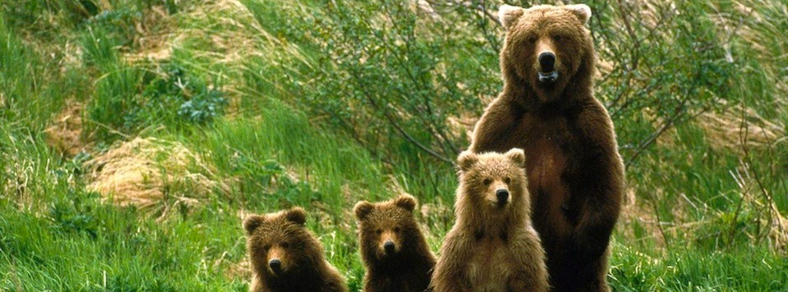

Home & Community Care Department
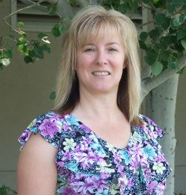

Weytk! Q’wemtsín Health Society Home and Community Care department services Skeetchestn Band, Tk’emlups te Secwepemc, and Whispering Pines/Clinton Indian Band.
The Home and Community Care objectives are to assist community members living with chronic and acute illnesses to maintain optimal health while preserving well-being and independence in their homes and communities; to support, families and communities changing needs; to assist clients and their families to participate in the development and implementation of the client care plan and to utilize available community support services where available and appropriate.
DeAnne Campbell, Hired April 2013
Home Care Department Manager

In order to meet these objectives our department:
- Provide a structured client assessment process
- Case management
- Home care nursing services
- Home support and personal care
- In-home respite support
- Establish linkages with other professional and social services
- Access to specialized medical equipment and supplies.
These services may assist clients on a short or long-term basis depending on their needs.
The home care department has seen an expansion of services utilized by community members in the past year and that also translates to an increase in the of staff within our department. We have introduced new Health Care Assistant casuals to our department to support the increased need of services in the communities and at Q’wemtsín Health Society. We will continue to see an increased demand of our services as a result of rising rates of chronic health conditions and the aging population. We are and will continue to see higher complex care clients that will be living in the communities that require support from our department. Our department staff has had 7894 encounters in the three communities with a total of 231 community members.

Our Home Care Nurses
Our team consists of Nurses with various experiences, backgrounds and skills. DeAnne Campbell is a Registered Nurse who has further training in Diabetes, Palliative Care and Foot Care. Lisa Perry is a Registered Nurse who has furthered her training in Diabetes, Palliative Care and Foot Care. Christine Lessmann is also a Registered Nurse who has furthered her training in Diabetes and Wound Management. Christine Left our department in December 2017 to pursue other opportunities. We are fortunate to have introduced Edna McLeod, LPN, to our team in November 2017. Edna supports the department with her extensive training in Mental Health and residential care.
DeAnne is the Home Care Manager and has an open-door policy which supports communication with the Home Care staff (as well as QHS staff), community members and other support services.
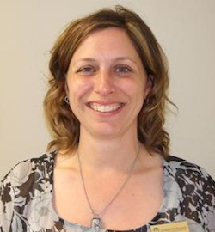

Lisa Perry-Hired April 2012
Home Care Nurse

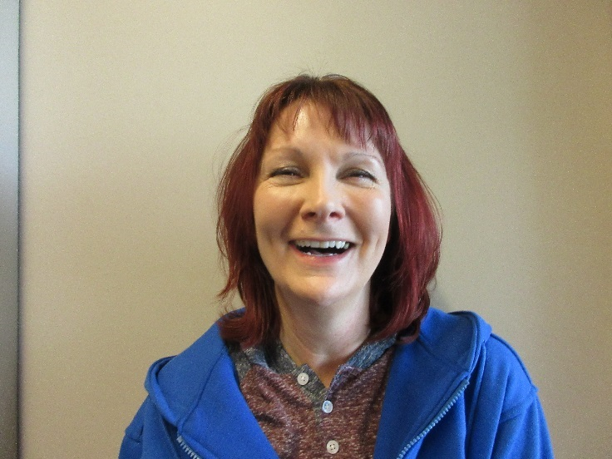
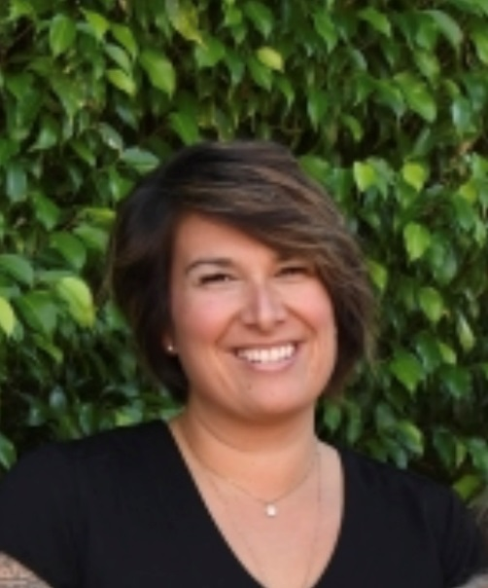

Edna McLeod-Hired November 2017
Home Care Nurse
Christine Lessmann-Hired April 2013-December 2017
Home Care Nurse

Our Health Care Assistants

Our Health Care Assistants (HCA) have been working in the Home Care Department ranging from over 12 years to just a few months. Each of our Health Care Assistants bring a vast array of knowledge from previous experiences to working in difference Health Care settings. They enhance and support our team with their knowledge and experience. The Health Care Assistants provide personal care services, respite and the SAILS Program. They also do Wellness visits at the Nurses request and they have been trained by the Nurses to check blood pressure, temperature, and pulse oximetry.
The purpose of the Wellness visit is to introduce the Health Care Assistants to frail community members and for them to feel comfortable and familiar with having a health provider in their home and to accept personal care services when required. Many of these community members who have received Wellness visits are now receiving regular services from the department. The HCA’s have seen 58 clients this past year for personal care services and to assist with activities of daily living.
The HCA’s also carry out Delegation of Tasks (DOT). This is the duty that a Nurse assigns and directs a HCA to perform and meet client needs such as administering medication from a blister pack. Nurses train and maintain ongoing monitoring for each HCA and assess each client needs on an ongoing basis. The Health Care Assistants have seen a total of 58 clients that have been supported by the Home Support Program.

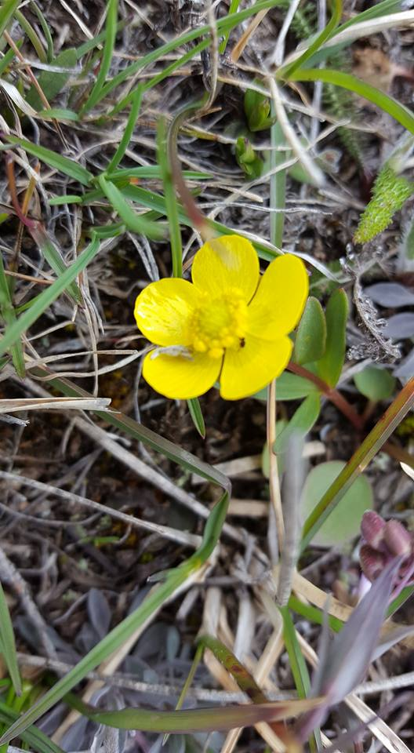
Number of Clients per community:
Tk’emlups te Secwepemc 40
Whispering Pines/Clinton Indian Band 5
Skeetchestn Indian Bands 13

Faces of Our Health Care Assistants Team
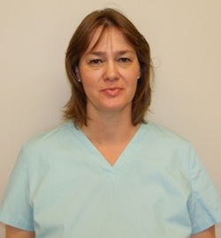
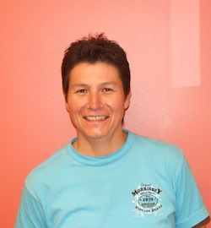

Kathrin Jules-Hired August 2007
Tiger Sperling-Hired August 2005
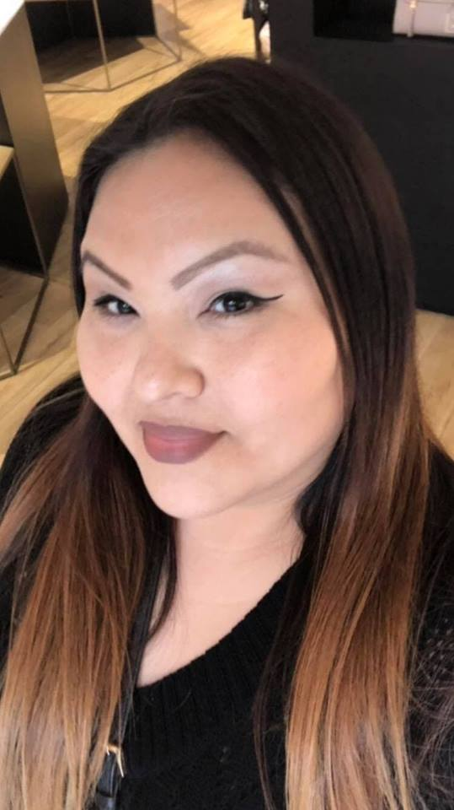

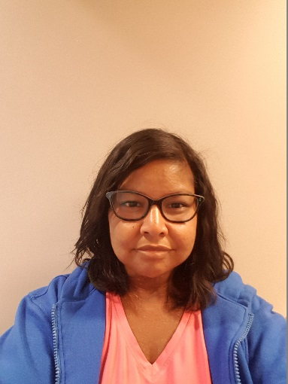

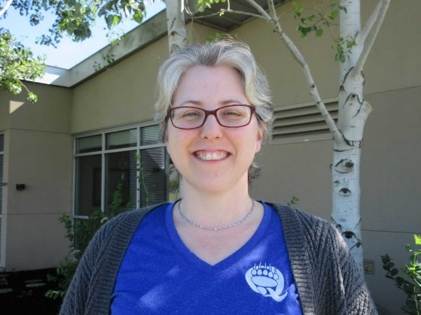
Natasha Negreiff-Hired February 2018
Virginia Sheep-Hired October 2015
Tanya Seymour-Hired September 2017

Tub Program
Our Health Care Assistants are trained to use the Century Tub that has 11 weekly spots which are always accessed and filled by clients on our program. We have also referred clients on our program. We have also referred clients to the IHA Home Health Community Tub Program if we have not been able to accommodate community members.
Medic Aid
Medic Aid is a personal emergency response system that is made up of a base unit and a personal help button that the client presses if needing medical assistance (ie 9-1-1). We have a total of 25 clients utilizing this service within the three communities. Some of the buttons are fall detection which is set up for clients who are at greater risk of falls. We also have two machines that dispense medication and are set up in the client’s home to assist with medication compliance.
Ensure
Ensure is a nutritional supplement that certain clients may need to support their diet and is not intended as meal replacement. In order for Band Members to access this service, they need to be assessed by their health care provider, receive a prescription and approval from their band for funding. We have 53 Band Members accessing this service. Laura (QHS Dietician) will be supporting our clients that require nutritional supplements during the year.
SAIL Home Activity Program
The SAIL Home Activity Program is a set of seven activities developed for adults receiving Home Support Services. This is a Province wide initiative that improves muscle strength, balance, endurance and reduces the risk of falling for our Home Support Clients. Physical activity and exercise are key to maintaining or improving Health. There are three levels which is dependent on each client’s abilities. Every client receiving Home Support services is set up to have the Health Care Assistants assist and encourage participation in the Sail program. Sail information can be provided to any interested community members.
Wound Management
Wound Management is a large component of the home care nursing role. Wound ranges from simple to complex and infected. We manage surgical wounds which may only involve changing a bandage to removing sutures or staples. We manage burns as well as diabetic and vascular wounds which may result in amputations. We collaborate with other Wound Clinicians to develop care plans that manage complex clients. DeAnne has attended Wound Conference to improve her knowledge on wound management and new product information. Wound products are paid for by FNHA once a prescription is received from the individuals Health Care Provider. We often liase with other health care providers to ensure that wound care products are received.
This year we have had 227 wound management encounters with our communities.
Diabetes
Diabetes has impacted many of our community members who require ongoing support and education. Our department provides one-on-one education and screening of all of our new clients. We have had Seabird Island at Q’wemtsín Health Society to screen for Diabetes which also includes Kidney and Eye screening. We have had Health Fairs where we provide information about the prevention and management of diabetes. We have screened about 218 members between screening clinics, Health Fairs, office and community visits. QHS has machines to test blood results and urine samples which are both tools that enable us to screen more frequently and assist with early detection of Diabetes. These machines provide immediate results. We offer support for medication management, nutrition and exercise. We also refer clients to our foot care provider and Dietician as well as the IHA Diabetic Clinic.
Chronic Disease Management
There are many other chronic diseases that require support within the three communities. The Nurses complete physical assessments on all of the new clients. Many clients require medication management from the Nurses that cannot be delegated to the Health Care Assistance. The Nurses review client medications and provide education about taking medication safely. Clients are provided with Client information sheet which lists:
- Medication
- Medical conditions
- Allergies
- Doctor
- Pharmacy
- Emergency contacts
Clients are encouraged to provide this information to other health care providers if they seek medical attention. Many clients and out health providers have voiced their appreciation in having this information at unexpected medical support.
Kidney disease, Cardiovascular disease, Cancer and Arthritis are just some of the other medical conditions that we manage in the communities. Clients often have more than one medical condition that requires support and management. The Nurses make well visits to frail community members to prevent issues from developing by being proactive which will therefore limit or eliminate hospitalizations. Safety is very important when managing clients in the community. Many clients choose to live at risk so our department strives to minimize and limit as much risk as possible. We make referrals to IHA Occupation Therapy to recommendations for bath chairs, railings, bars, grabs and mobility aids. We refer to the Housing Department for installation of safety equipment needs. For urgent equipment needs, we refer to the Red Cross Equipment loan program. They provide equipment on a short-term basis until the client’s equipment has been approved and processed by NIHB. We also assist clients with the coordination of transportation to and from health-related appointments that have been arranged. Our department collaborates and communicates with other Health Care providers to facilitate client health care needs.

We coordinate with:
- Dentistry for oral health and denture fitting
- ensure clients have Medic Alert where appropriate
- refer for orthotics
- People in Motion for disability parking decals
- Hearing clinics for hearing aids
We have a close a very close working relationship with IHA Community Home Health who supports our role and community members. We refer IHA Home Health to assist with clients needing assistance out of our regular business hours or for services that QHS does not provide. Therefore, we do share some clients with IHA Home Health. We require Home Health to complete home assessments for facility placement and facility respite. IHA also sees some of out community members for personal care services and wound management. The department Nurses also make hospital visits for case management and discharge planning to ensure that clients needs are met and to elicit a smooth transformation home.
There are many external community and IHA services that our department accesses for our clients but there are also many internal services within QHS that are accessed as well. We been fortunate enough to refer clients to our Mental Health, Dietician, Naturopath, Massage Therapy, Nurse Practitioner. Doctor, Community Health Nurses and Dentistry.
The Home Care Department encourages clients to be independent as possible with our assistance and support to ensure their needs are being met. Our support is client driven and client specific. We often find ourselves meeting with clients where it works for them whether its in their home, in their garden, community event, hospital or the Health Centre. Each client situation is unique and we ensure that their needs are met in a respectful, timely manner. Client visits can vary from a one time visit to a complex client that requires daily visits.
The Home and Community Care team makes every effort to support the clients and community members. The have demonstrated their dedication to the department and communities by their quality of care that they provide to their clients. They continue to improve and expand upon their roles as care providers and being active members of the communities.
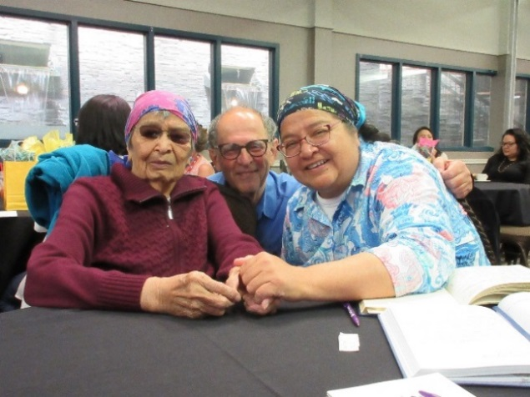
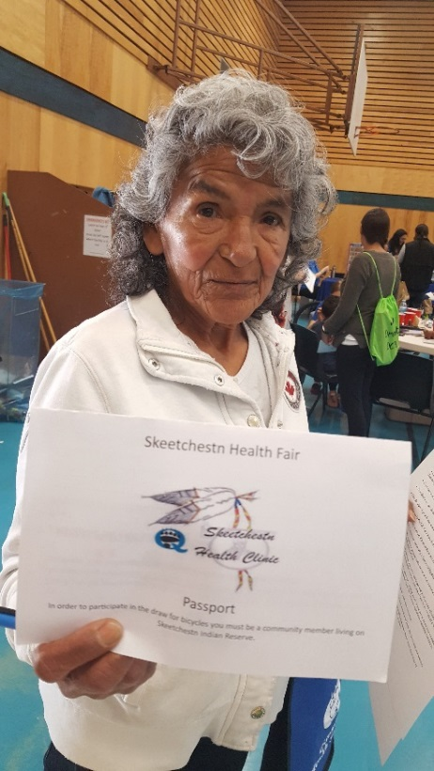

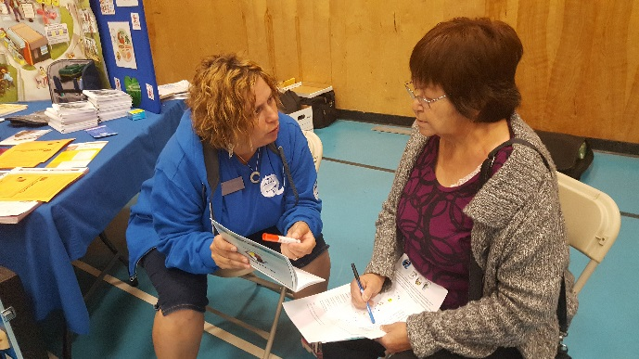

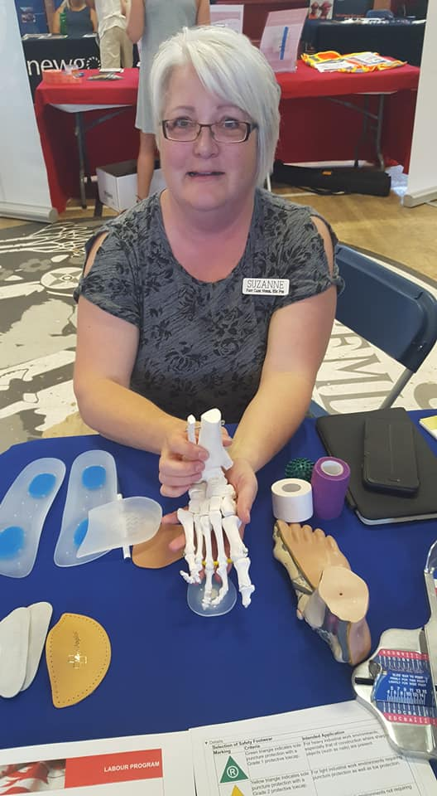
Foot Care Nurse

Suzanne is a Licensed Practical Nurse with a Bachelor of Science of Podology with Advanced Foot Care training, Certified Podologist and Certified Master Pedicurist. Suzanne has an extensive knowledge base and shares this with staff as well as clients. She has clients for Ttes three times per month, SIB twice a month and WPCIB once per month.
All of the clients that have been on our waitlist are now on our Foot Care Program, since the department has made changes to the scheduling. Suzanne has had 270 Foot Care appointments between the three communities. Clients per community:
Tk’emlups te Secwepemc 38
Skeetchestn Indian Band 20
Whispering Pines/Clinton Indian Band 4
Suzanne Marcel-Hired November 2014

Foot Care program Year End Report
Snapshot of Footcare Services

Positive
- Reduced wait times to access program
- Streamlined communication between departments
- Use of electronic charting
- Reduced time of each visit 30mins/ with initial assessment 45mins.
- Increased number of clients able to access program
- through assessing individual needs of each client vs. standardized scheduling.

In the Works
- Monthly “Foot Facts” information on common foot conditions and issues.
- Display board (in Footcare room) with various foot care products/aids for improving foot comfort and preventing/reducing problematic foot issues.
- Education “Sole Moments” 5-10min learning session for all departments present during sharing /meetings.

Hurdles within program:
  - Unable to connect with some clients (contact phone, etc)
  - Missed appointments/no shows
  - Program is currently designed/funding; not able to reach some age groups that would benefit from preventative footcare, rather than waiting until there is a problem.
  - Stigma regarding feet/footcare; feet are one of the least talked about body parts

Foot Care Services
Objectives:
Offer footcare services to members utilizing the Q’wemtsín Health clinic & Skeetchestn & Whispering Pines Communities.

Footcare services for clients with health conditions/limitations that put the client at a greater risk for infections and/or complications relating to compromised health conditions.

Goals:
- Educate promote healthy footcare practices both in clinic & in home.
- Providing Risk Assessments to ensure client’s

Outcomes:
- Increase volume of clients through program.
- Improve on providing more educational moments/sessions/info for all members.
- Reduce/prevent foot conditions/infections/loss of limb /other complications related to care of feet.

By: Suzanne Marcel

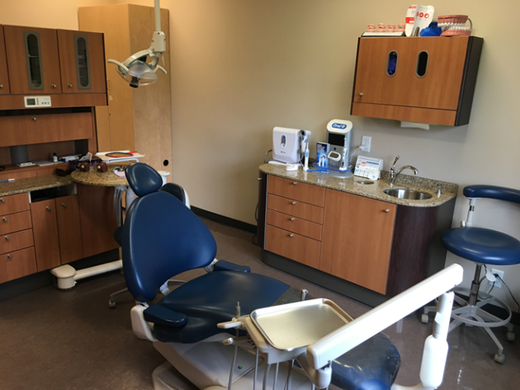
Q’wemtsín Dental Clinic
June 2018

Q’wemtsín Dental Clinic provides dental services to on and off reserve band members from our three communities: Tk’emlúps, Skeetchestn and Whispering Pines/Clinton. Dr. David Ciriani and Dr. Corbin Sallis along with their Certified Dental Assistants Alyssa and Sadie, see clients 2—3 days a month while hygiene services are provided by Crystal 3–4 days a month. The QHS Dental Team provides each client with individualized compassionate professional care. We practice in a modern two operatory clinic providing state of the art dentistry.

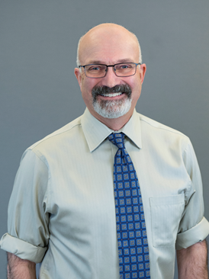

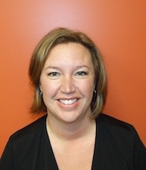

Dr. David Ciriani
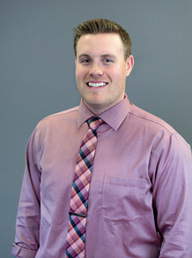
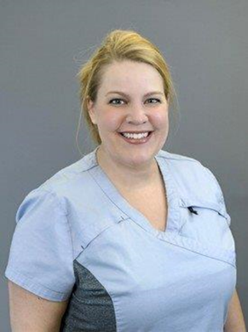
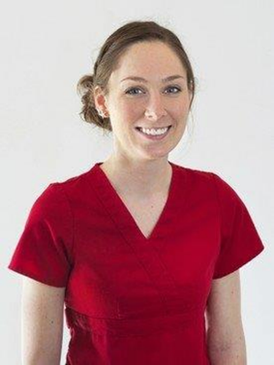
Dr. Corbin Sallis
CDA Sadie
CDA Alyssa

RDH Crystal Chartrand

Dental Services Available at QHS
· New Patient Exams  · Specific/Emergency Exams  · Recall Exams  · Restorations (amalgam & composite fillings)  · Extractions  · Hygiene  · Biopsies |  | · Oral Sedation  · Impressions/Wax Bites/Occlusal  · Night Guards  · Dentures  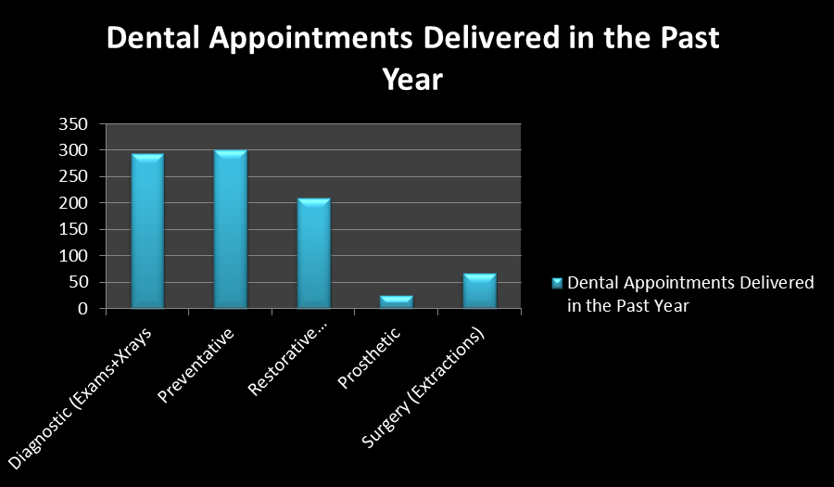  · Denture Adjustments/Repairs

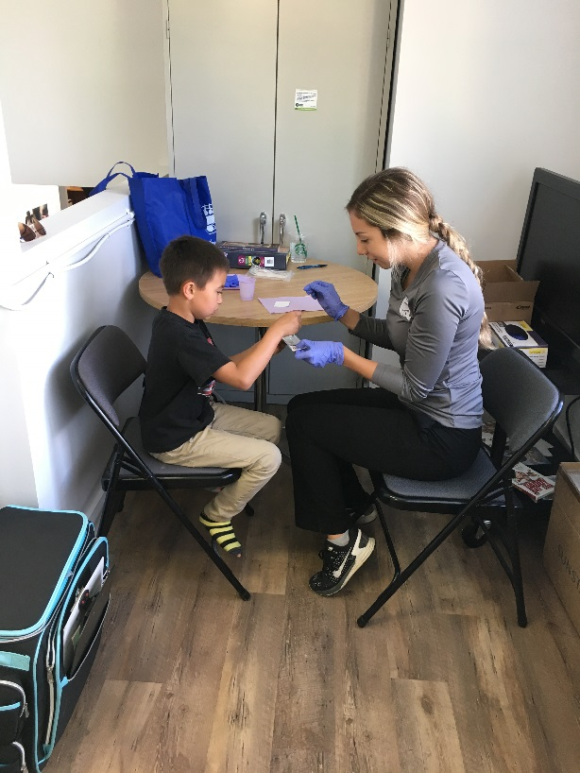
Children’s Oral Health Initiative
June 2018
Which communities are eligible for COHI services?

In addition to the three communities Q’wemtsín Health Society services: Tk’emlúps Indian Band, Skeetchestn Indian Band, Whispering Pines/Clinton Indian Band; we also provide services to Adams Lake Indian Band, Little Shuswap Indian Band and Simpcw First Nations

What is COHI?

Children’s Oral Health Initiative
COHI is a preventative program for early childhood tooth decay.
Who is COHI for?
COHI is for children 0-7, their parents and caregivers and pregnant women.
What sort of services does COHI provide?
COHI services include annual screenings, fluoride varnish applications, sealants and oral hygiene education. We also provide toothbrushes, toothpaste and floss for our COHI families.
Who are the COHI providers in our communities?
Crystal Chartrand is our Registered Dental Hygienist. Courtenay Campbell, Natasha DeNeef and Coreen Ironside are our community COHI Aides.
Where might our children access COHI services?
The COHI Team can be found delivering dental services in our schools, daycares, nursery schools, pre-school’s, head starts, community events and other social gatherings.

Dental Sealants in the Community

Portable Equipment Use
Annually, Dr. David Ciriani comes out to each of our communities to do sealant exams on our school age children. Dr. Ciriani is checking each child’s mouth and is specifically looking at their 6-year-old permanent molars. He then advises us which molars require sealants. A sealant is a special flowable material applied to teeth that are healthy but have deep grooves. |  | 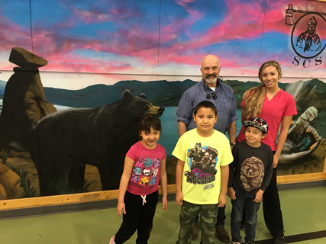  We then take our portable dental equipment out to each community to apply these protective coatings to the recommended children’s teeth. This procedure usually takes 30-40 minutes per child. By delivering these services on site we are minimizing missed school time and parents don’t need to miss work.

Dental Clinic Community Outreach

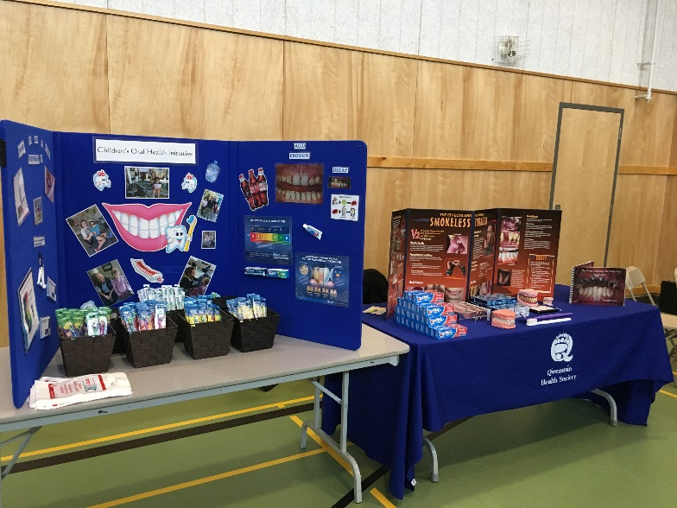
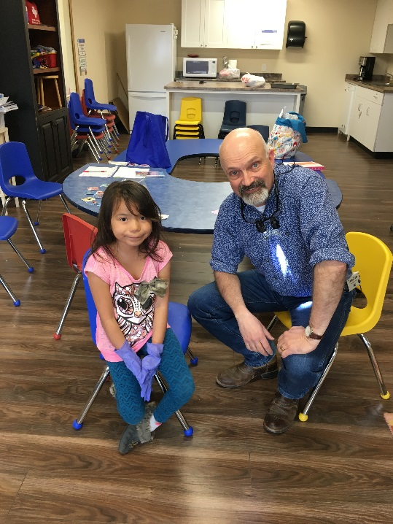

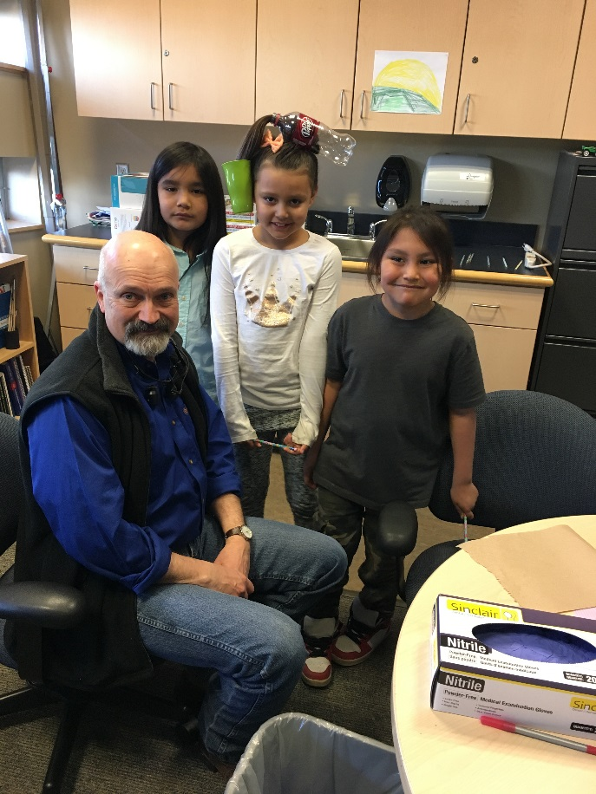

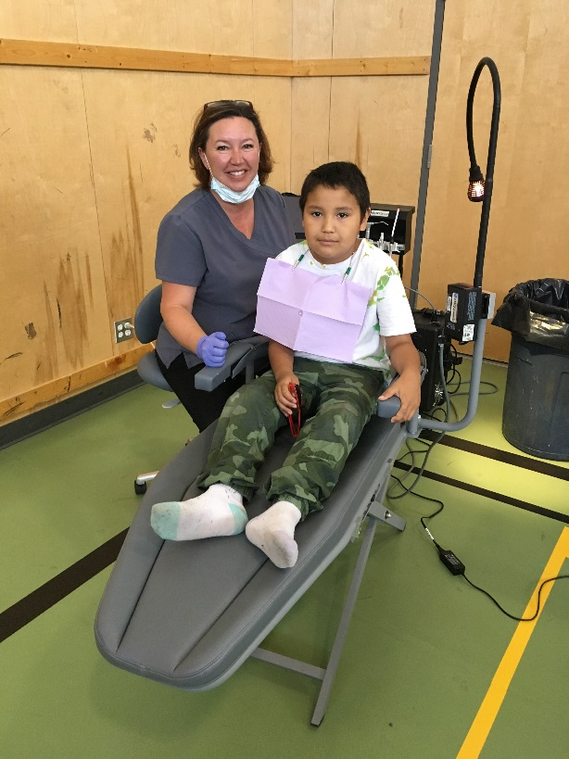

COHI STATS 2017-2018

Community Health Nurses
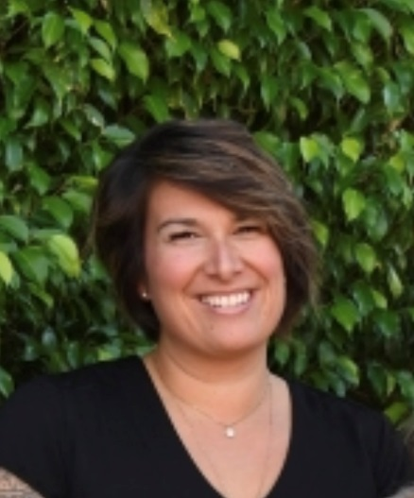

Weytk, my name is Christine Lessmann and I have been one of the Community Health Nurses working at Q’wemtsín Health Society since 2013. I currently work Monday, Tuesday and Wednesday and my primary focus is school health at Sk’elep School of Excellence and Harm Reduction. I am a Community Health Nurse for all of the communities; however, I primarily work with Tk’emlups Indian Band and Whispering Pines Indian Band community members.

Sk’elep School of Excellence K-7
Throughout every school year staff members are offered Anaphylaxis training, Diabetes training, flu vaccine and TB skin tests. When requested staff are provided with resources for subjects on health and given support when concerns for students arise. Annual hearing screening for the Kindergartens and any other student’s teachers had concerns were completed with a total of 18 students being assessed resulting in 3 students referred to public health for further testing. In 2013, 94% of the students at Sk’elep had fallen behind in their immunizations for a variety of reasons. Currently 72% of students are fully immunized according to the BCCDC immunization schedule. This percent will vary every year with students leaving and new students joining the school. Our goal is to have the school at a minimum each year of 80% compliance.

Comprehensive Sexual Health, multiple health and wellness topics and body systems education and support was provided as requested from teachers to Grades 4-7. In partnership with TIB Social Development Lesa Frezie and TIB Youth Leadership we held an eight-week Girl Power and 2BBoys programs for ages 8-13. These programs also includes youth members that attend other schools in Kamloops. These programs provide a safe area for students to continue to learn subjects on healthy relationships, self-esteem, diversity, body changes, self – regulation and communication. All these programs are continuous throughout the years and Christine and Sarah very much enjoy working with the students and staff at Sk’elep School of Excellence.

Harm Reduction – Naloxone
In recognition of the Fentanyl crisis QHS became a Naloxone distribution site in October 2016. 232 kits were handed out in 2017 and an additional 143 have been distributed since. In addition to the first 16 workshops from 2017 there has ben another 8 workshops held for communities, to all families, high schools or supporting agencies requesting training. With little turn out to community sessions, kits and education continue to be provided on a one to one bases. On behalf of QHS I would like to thank Dave Manual for his assistance with the workshops held for the TIB community and acknowledge his continuous dedication to providing kits, education and support to as many members as possible.

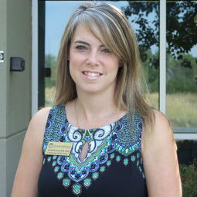
Weytk, my name is Sarah Bennett and I have been one of the Community Health Nurses working at Q’wemtsín Health Society for the past 12 years.
Although I am a community health nurse for all of the communities we serve, I primarily work with Tk’emlups Indian Band and Whispering Pines/Clinton Indian Band community members.

CPNP Program
The Canadian Prenatal Nutrition Program (CPNP) is a community-based program that provides support to improve the health and well-being of pregnant women, new mothers and babies in our community. The CPNP’s main objectives are to: provide support for healthy maternal nourishment; provide support, education, and awareness around breastfeeding; and nutrition screening, education and counselling for pregnant women and new mothers living within our community. Tk’emlups Indian Band had 16 births over the year, while Whispering Pines/Clinton Indian Band had no births during the year. The CPNP program served a total of 38 women and families from both TIB and WPCIB over this past year. These women and their families received grocery vouchers, resource packages with information and education and individual nutrition counseling as needed.

Maternal Child Health Program/FASD Program
The Maternal Child Health Program/FASD Program is a community-based program that provides support to improve health outcomes of First Nations women who are pregnant and families with infants and young children who live on reserve. The Q’wemtsín Health Society Maternal Child Health and FASD programs are collectively called the ‘Circle of Life Program’. Tk’emlups Indian Band and Whispering Pines/Clinton Indian Band have a total of 78 children who are a part of this program. This program is made up of families who have children ages newborn to 6 years of age and/or pregnant women. We provide prenatal and postnatal support, and support to parents and families until the child is in their 7th year.
This year there were a total of 16 babies born to client’s living on the Tk’emlups Indian Band. In Whispering Pines/Clinton Indian Band, there were no births this year. The majority of the babies born within the TIB community were born with a healthy birth weight. There were 4 babies born over 8 lbs 11 oz. and there were no babies born at less than 5 lbs 9 oz. and only 1 baby was born prematurely. Of these babies 16 were breastfed at birth, 7 are still breastfeeding, 4 breastfed until 6 months, and 5 breastfeed for only a few weeks due to issues with breastfeeding. BF issues that have required support over the past year are mastitis, low milk supply, and challenging latch. Royal Inland Hospital, our local hospital, no longer employs a lactation consultant, which would have greatly benefitted these mothers with their breastfeeding challenges, as all of the challenges started immediately after birth in the hospital environment. Having a hospital lactation consultant would provide the support new mothers need in hospital ensuring breastfeeding is initiated successfully, thus leading to higher long-term breastfeeding rates.

Currently, there are 5 prenatal families in the program at this time, and 4 babies have been born between April 1, 2017 until now, which will be captured in the report for 2017-2018.

Welcome Baby Ceremony
We host an annual Welcome Baby Ceremony every year to celebrate and welcome all the babies that have been born on reserve in the community. In the 2017-2018 ceremony, 14 babies and their families attended the celebration. The ceremony included drumming from our local drum group, a healthy dinner, and each baby was wrapped by an elder in their own unique blanket made especially for them by a local quilt maker.
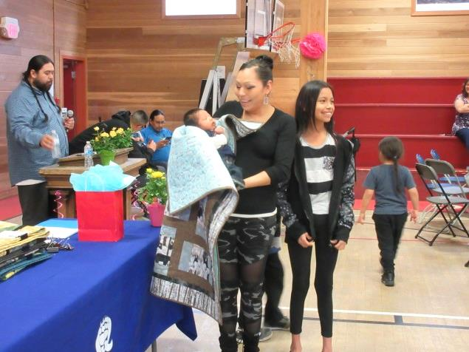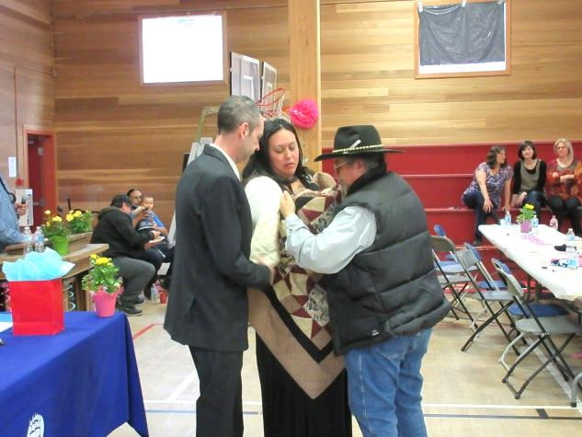
Play Group
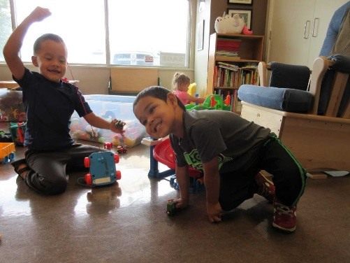
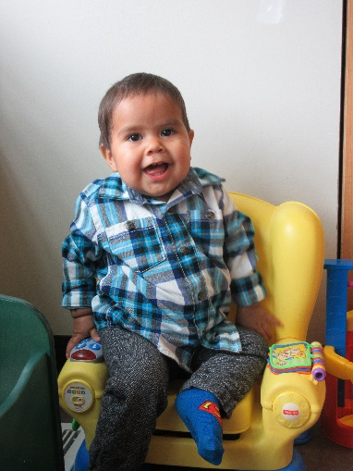
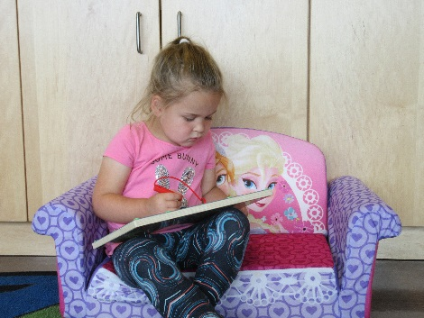
We host a play group at Q’wemtsín Health Society in collaboration with the band social development department. Once a week, we offer play group to families who want to bring their children to drop in at health centre to connect with other families and connect with the community health nurse and family support worker. This is an opportunity for families to build relationships in the community with other parents, get information about community events, or ask questions about child development, child health, parenting, etc. This past year, we have hosted 16 play group sessions. In total 25 people attended, averaging 5.77 people each session. Many children attended, including 16 children who were ranging in age from newborn to age 8. The remainder of the people attending were parents and/or caregivers of the children attending.

Preschool and Kindergarten Health and Wellness Day
We host a preschool and kindergarten health and wellness day each year. This past year, 44 people attended, in which 30 of these were children either living on reserve in the TIB and WPCIB communities or attending daycare at one of the daycares or preschools on the TIB reserve. At this health event, we invite 3-5-year olds to attend with their families, to enjoy a fun filled event that focuses on health and wellness of the preschool population. Each year, we invite Interior Health Audiologists to attend to screen children’s hearing to ensure that they are ready to begin school with the best hearing and speech possible. If required, referrals are initiated for follow up with the audiology department or the speech department. In total, 30 children were assessed by the audiologist from IHA at this event in 2017. Of these 30 children, 9 were referred for further audiology testing, and/or to the speech and language department at IHA. In addition to screening hearing, we also offer dental screening by our COHI department at this event. We offer parents information about preparing their children for kindergarten entry and ensure that all of the children leave with a gift bag full of goodies that will keep their minds and bodies active during the summer months. It is at this event that we connect with parents to remind them that prior to school entry, it is important to have their children’s school entry vaccinations done to ensure that they are completely up to date with their immunizations.
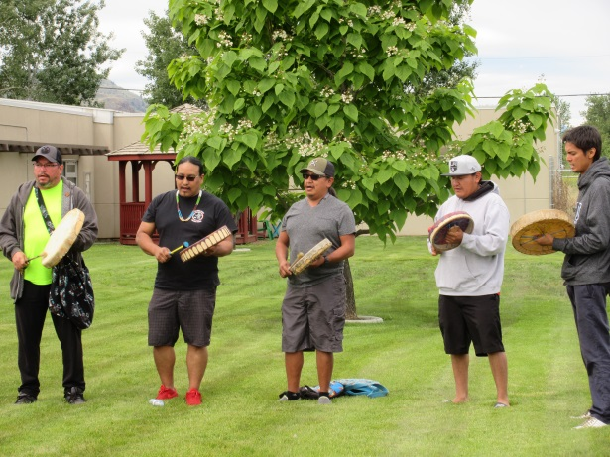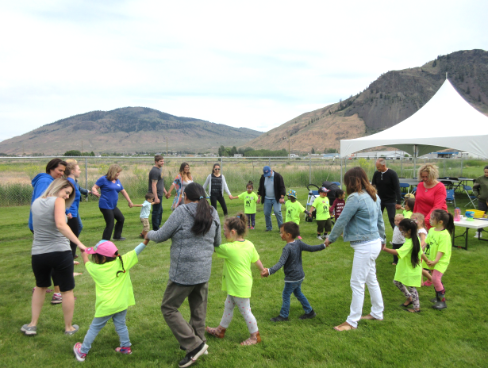

Communicable Disease Control
Within the last fiscal year, the Community Health Nurses carried out provincially and federally mandated Communicable Disease Control Program initiatives within the community. These included routine childhood and adult immunizations, annual influenza immunization, tuberculosis screening, communicable disease outbreak surveillance and compiling and submitting reports of results from each of these areas.

All Vaccines
250 TIB members were immunized
8 WPCIB members were immunized
63 staff and client’s whose charts are not yet connected to a community were immunized
Please see Immunization Coverage Report for Tk’emlups and Whispering Pines/Clinton Indian Bands attached. (Add immunization coverage report)

Influenza
221 influenza vaccines were provided to TIB clients
6 influenza vaccines were provided to WPCIB clients
13 influenza vaccines to staff at QHS

TB skin tests
28 skin tests administered to TIB clients
1 skin tests administered to WPCIB clients
9 skin tests to staff at QHS

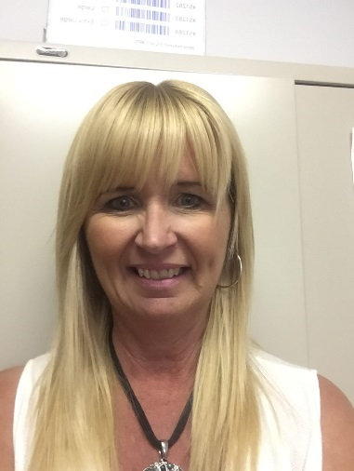

Weytk!! My name is Diane Procter, RN, BSN, BA and I am one of the Community Health Nurses employed by Q’wemtsín Health Society (QHS).

Although I am a community health nurse for all of the communities we serve, I primarily work with Skeetchestn Indian Band community members. This August will mark my 12th anniversary with QHS.

Skeetchestn Health Clinic
The Skeetchestn Health Clinic continues to operate across from the Skeetchestn Band Office and it has become increasingly busy. I continue to work alongside the Lee-Anne Deneault who manages the clinic and we have added Erin Hewitt to our Skeetchestn team to cover the front desk at the clinic as needed. Welcome Erin!!!
The clinic continues to offer a variety of health and wellness services including bringing a General Practitioner (MD) out to community as well as a Nurse Practitioner. The clinic continues to offer the services of a Naturopathic Doctor and Registered Massage Therapist and the services of a Mental Health Counsellor. Q’wemtsín Health Society has recently welcomed Laura Kalina, a registered dietician to the QHS team and Laura is also bringing her services to the Skeetchestn clinic, school and community.
This year, the Skeetchestn Health clinic and staff have been involved in many events including:
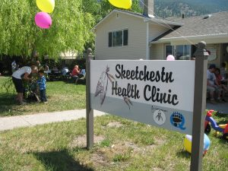

Families and Tots group
We continue to host a monthly Family and Tots group which includes sharing food, stories and having fun. We usually host from 3-6 families, but everyone is welcome. Some of the highlights included making fresh ingredient smoothies (with kale) and homemade pizza made with quinoa crust. Our dental team is often on hand and provides dental screenings to children at these groups. Our goal is to create a happy space for parent and community driven discussion.
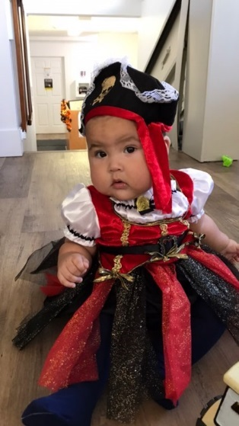
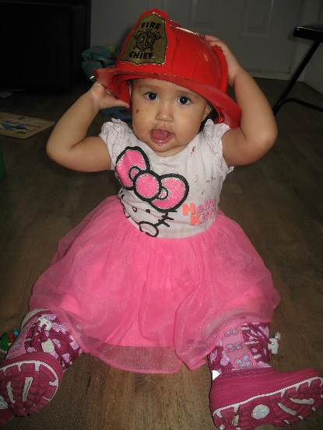

Annual Christmas Open House
The clinic hosted an annual Christmas Open House which allowed us to share food, refreshments and Christmas spirit and good wishes. This year we hosted upwards of 60 community members and staff.

Baby Welcoming Celebration
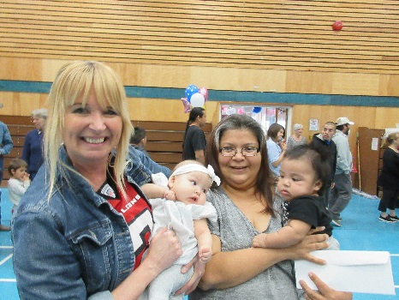
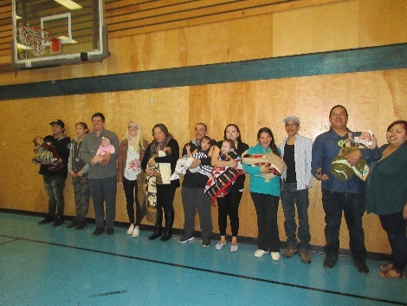
This year, our Baby Welcoming Celebration honored seven babies and families. As in previous years the event was MC'd by Skeetchestn Indian Band Councillor Terry Deneault and the Skeetchestn School Drum group opened the ceremony in a good way!!! What a great celebration of babies, families and community!!!!

Preschool/Kindergarten Day
Our annual preschool/Kindergarten Wellness Day was held in May and was attended by close to sixty children and adults. The event offered a mix of fun, food and health. Fun and food included a bouncy castle and face painting as well as macaroni, chicken fingers and veggie/fruit skewers. Health included the services of our dental hygienist/COHI team who did dental screenings, and we welcomed back Brad Orr from Interior Health who provided hearing screenings on fifteen children with one referral for follow-up. I was also on hand to provide health and immunization information throughout the day.

Bike Rodeo
In June, QHS teamed up with Skeetchestn Social development and the rural RCMP departments to bring a bike rodeo to the community. QHS provided pizza, helmets and I assisted with helmet fittings. What is exciting to note was that when QHS hosted the rodeo two years ago many children who attended didn't have helmets and QHS supplied about eleven helmets. In contrast, only three of fifteen children who attended this year needed helmets or a helmet replacement. It is encouraging to see that bike safety is being practiced by some of the youngest community members!!!
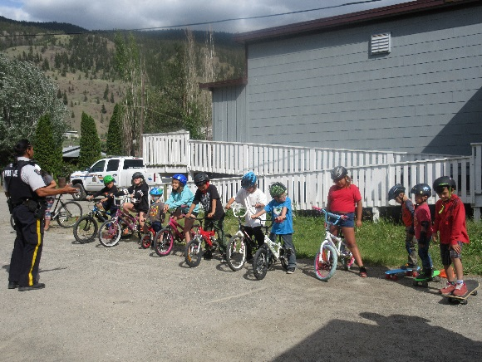
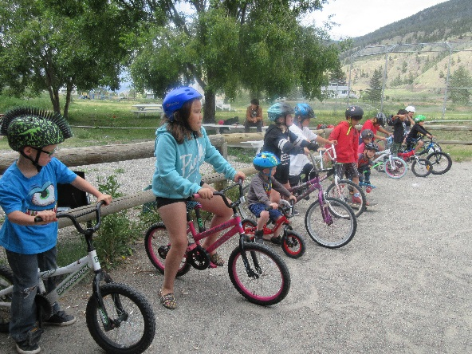

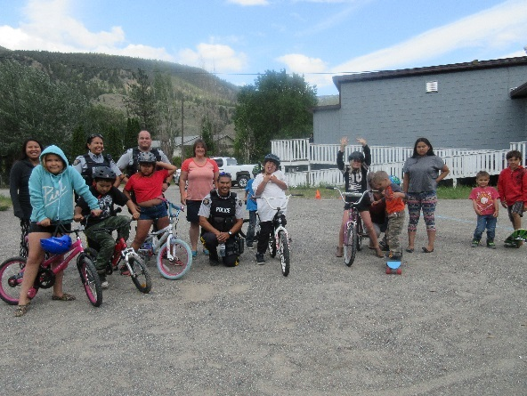
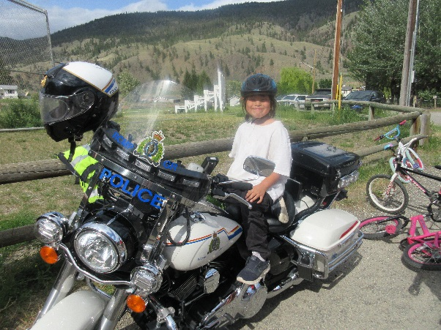

Drug Awareness/Naloxone Training
In January, I teamed up with Cpl James Toye of the Rural dept of the RCMP and an RCMP member from the Kamloops Drug Squad for an evening event held at the Skeetchestn gymnasium. Following the drug presentation by RCMP, I provided naloxone training and on-hands demonstration. Approximately 15 people attended with about the same number of naloxone kits distributed. In the previous year I teamed with the SIB social development department and provided naloxone training to band staff. In total, about 50 naloxone kits were distributed at this training. Naloxone training continues as needed with potential plans for another session in the fall.

Flu Clinics
This past year, flu clinics were held at the Skeetchestn Health clinic. In total, 85 Skeetchestn Community members received vaccinations. This number breaks down as follows: 11 children aged 6 months to 8 years, 9 children aged 9-18, 47 adults between the ages of 19-64 and 18 elders aged 65+ received flu shots. It was a successful 2017/2018 season and we look forward to a successful campaign in 2018/2019.

Skeetchestn Community School
I am also the school health nurse at Skeetchestn Community School. This past year I provided routine immunizations to kindergarten students, and students in grades 6 and 9. I also provided TB skin tests to SCS staff. During an in-service day, I provided Anaphylaxis and naloxone training to all staff. In classroom, I provided drug/alcohol education/naloxone training to high school students and all participants were eager to take home a naloxone kit.
I also provided hand hygiene and teaching on private body parts to K-1 students and held a Girls Group (as scheduling allowed throughout the year) to girls aged from 8-10 with a focus on puberty and hygiene. In the spring I set up a booth at the Skeetchestn School career fair and administered blood sugar screenings to over 50 students from several schools. It was great to see students take an interest in discussing health, blood sugar levels and diabetes. I also took part in the Rattling Ramble as part of a team from QHS. I hope to be able to participate in all of these (and more) health and wellness events next year!!!

Professional Development and Training
I was able to attend many training events this year, far too many to list but here are a few of the highlights. I attended workshops on De-escalating Potentially Violent Situations, Secondary Trauma, Suicide Alertness for Everyone and Internet Safety. I attended a four-day workshop hosted by Darian Thira on the Effects of On-Going Trauma and Colonization and I attended Art Hister’s presentation on “Laughter is the Best Medicine” which brought humour to some hard to talk about health topics.
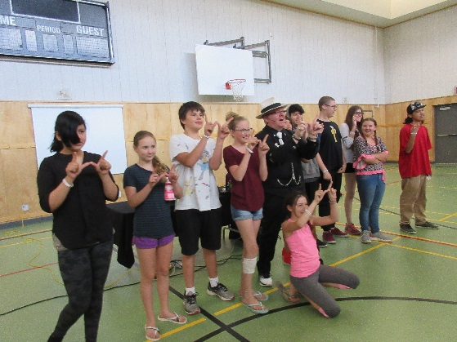
I attended the 8th International Research Conference on Adolescents and Adults with FASD through the Interprofessional Continuing Education at UBC and I also attended the annual Communicable Disease Workshop hosted by FNHA. One of the highlights of my year was being honored at the FNHA Aboriginal Nursing Conference with a 10-20-year service award for service in First Nations Communities. I was truly humbled and so honored to be recognized by the FNHA team and my colleagues and peers.
In closing, I would like to thank Q’wemtsín Health Society, the QHS board of directors and the communities of Tk’emlúps te Secwépemc, Skeetchestn and Whispering Pines for supporting me and allowing me to continue to do the work I do.
Kukwstsemc and I look forward to another year!!!
Diane

Primary Care Services (General Practitioner and Nurse Practitioner)
Dr. Shirley van der Merwe provides an all-day clinic at QHS on Tuesdays with one Tuesday ever six weeks out in the Skeetchestn Community. Our Nurse Practitioner Laura FitzGerald provides clinics at QHS on Monday afternoons and all-day Thursdays and Fridays. Clinic is provided out in the Skeetchestn Clinic every 2 weeks on a Thursday with the NP.
The following graphs show how many appointments per community the doctor and NP had throughout the fiscal year between April 1st, 2017 and March 31st, 2018.

Naturopathic Services
Dr. Melissa Bradwell provides a wide range of naturopathic services to our band members. Clinics are provided at QHS, Skeetchestn and Whispering Pines on Mondays and Wednesdays.
Dr. Bradwell seen a total of 112 members with 411 encounters over the course of our fiscal year.

Massage Therapy
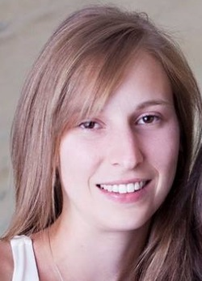

Meaghan Atchison is our Registered Massage Therapist at Q’wemtsín Health Society. Meaghan works with our elders and members in chronic pain to help alleviate discomforts. Meaghan listens to her patients and moves very thoughtfully through treatments to provide her patients with the best results.
She is furthering her education in Craniosacral Therapy, a gentle, non-invasive therapy focusing on whole body health. Meaghan works with members of Tk’emlups te Secwepemc, Skeetchestn and Whispering Pines/Clinton Indian Bands.

Meaghan has really become a part of the QHS family and the patients have really come to care for her.
Last fiscal year (April 1st, 2017- March 31st, 2018) Meaghan saw a total of 65 patients and provided 338 treatments. The graph below breaks it down into communities.

Mental Health Clinician
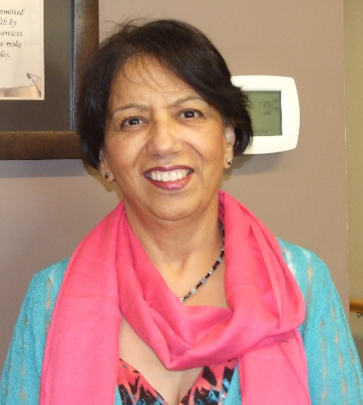

Since 2009, I have worked at Q’wemtsín Health Society as a Mental Health Counsellor and aim to provide an integrated and ethical service with prime respect for the client’s safety and confidentiality. Working with a multidisciplinary team and the individual needs of the client have been a constant source of learning for me and adds to my initial education and training in providing services which fit the client’s needs. Though I would consider my approach to be eclectic, I use Cognitive Behavior Therapy, Brief Solution therapy, Experiential, Supportive and other evidence-based modalities as needed. Working with individuals, families and community are a definite requirement and QHS allows me the flexibility to do that with positive results.

This year has been extremely busy, especially with the loss of community members and the resultant trauma and grief for their family and friends. It has further triggered the Post Traumatic Stress for the Residential School survivors and their families. Q’wemtsín Health management has recognized the need and arranged for workshops and training for all staff and some community members with Darien Thira on “The community is the Medicine” and “From Wound to Wellness”. The four-day training was very educative and helpful.

Also, another day of services for Mental Health support has been added since April 2018 to meet the needs of the three communities of Tk’emlúps, Whispering Pines and Skeetchestn. It enables me to provide better and more timely services to my clients who use Q’wemtsín Health Services.

Flow Through Funding - Skeetchestn

Health Services, Brighter Futures, NNADAP, Mental Health, Solvent Abuse
Skeetchestn Social Development Team’s focus in 2017-2018: Unity, Well-being and Team Work.
Well-Being
Looking back at the year we asked ourselves “but where did the time go!”
The Skeetchestn community was affected by the floods in the Spring,, under wildfire alert for several weeks in July and then had to evacuated for close to 3 weeks in August. You can imagine the impact these natural incidents, especially the wildfires, had on everyone in the community and how we all had to be united, work together and ensure everyone’s well-being during and after the event. And so we did.
During the evacuation, we moved our Social Department Team in Kamloops at the Sandman Centre where most evacuees were fed and some were staying. Qwentsin Health Society also allocated staff on-site to assist with needs for medical services and Counselling. Using a rotation basis schedule, we ensured someone was always there to assist, to guide, accompany or even entertain! Report updates were posted every morning, briefing with other agencies on-site were taking places, we also offered fun activities for the children and families. Overall our services were well orchestrated and our members received great care and support during the evacuation and once back home.
Delivery of food, deliver of wood, increase in home care services, several community feasts for lunch and dinner, helped us monitor and evaluate of the community pulse and how everyone was doing. We observed that the people we closer than before, when we returned home and with a stronger desire to engage in community activities.
We did see an increase in visits to our health and wellness professionels, which was very positive, our people wanted to talk and share and they trusted our staff.
Before and after the flood and wildfires:
The year started nicely with a Spring retreat for our Elders where were incorporated workshops on identifying what it mean being an Elder and how to ensure one’s well-being at a certain age; we touched on physical health, nutrition, responsibilities, respect and inner peace.
12 Elders participated
We then hosted a retreat for adults with a focus on building and maintaining healthy relationships. We touched on the most important relationship to nourish, which is with yourself, and what this means; a sense of self, balanced life, healthy choices, and setting boundaries. 19 Adults (32-56yr) enjoyed this 2 day retreat.
A Cultural Family retreat took place in February. We hosted 103 community members from 2 to 81 year old!
Everyone enjoyed one of the many activities outdoor and indoor, the cultural workhops, the feast and the family games that were aim at “trusting” each other.
Our Youth program hosted a Youth conference here at Skeetchestn with 2 days and evenings pack with uplifiting activities; guest speakers and hip-hop singers Dani and Lizzi delivered healthy activities and offered alternatives
instead of using drugs and alcohol. 46 Youth participated and 16 adults
We hosted two Drug awareness Naloxone training with QHS Nurse and presentations by RCMP officer
62 people in total participated (14 to 56 yr).
Our team work very closely to facilitate 2 men’s night and 2 ladies night which helped create trust and open up communication around sensitive topics. This type of event inspires us as a good model for upcoming presentations and workshops.
At a glance
During 2017-2018 we did not see any increase in our drug and alcohol treatment referrals, but we did an increase of service referrals in the Kamloops area and on-reserve such as Counselling and Family Support.
We emphasised our message on the importance to keep active and do fun activities to stay mentally and physically active through: wellness days, field trips off-reserve, Horsemanship Program, swimming at the Tournament Capital Centre, Zumba, Secwepemc Dance, Ball Hockey, cooking lessons, canning workshops, Valentines Family Dance, Soccer Quest, Rock Climbing, and much more… Our partnership with Right to Play Canada continued for a second year in a row, keeping our staff well-trained and offering great sport and leadership opportunities for our Youth.

Flow Through Funding - Tk̓emlúps te Secwepemc
Tk̓emlúps te Secwepemc (TteS) flow through funding is administered through the Community Services Department. Each fiscal year the Community Services team strategizes both internally, and with other departments (ex. Education) to decide on an annual strategy to accomplish the strategic and comprehensive community wellness goals in the areas of physical, mental and social health. The annual work also follows the TteS Comprehensive Community and Strategic Plans.
Brighter Futures, NNADAP, Community Health Representative, Mental Health and Solvent Abuse funding are then administered based on the planning. With an increase in new parents, for example, this year TteS added in breastfeeding education and positive parenting classes. We continued to experience year-over-year increases in the need for one-to-one counselling. Due to an increase in overall health needs TteS has also requested FNHA revisit the flow thru funding model for TteS, as we believe we are underfunded.
Mental Health
Mental Health funding is directed for prevention, intervention and postvention, education and resource supports. To that end, TteS offered workshops for reducing depression, suicide prevention, naturopathic and traditional medicine approaches to mental health. To increase the success of each workshop, resource manuals and workbooks were provided whenever possible as alternative learning methods.
As mentioned above, there was an increase in need for direct supports and we answered that need. Over sixty (60) new referrals to counselling were made, and an additionally band members referred to counselling supports in 2016/17 continued their healing journey with direct counselling. We worked with FNHA and QHS to optimize funded counselling but have found with so few FNHA approved resources in Kamloops, and so many of those seeking support residing on reserve, that the majority continue to utilize the mental health funding from the TteS flow through. Due to the small selection of approved counsellors, band members report the FNHA counsellors are often booked too far into the future or are unavailable when the need is acute.
TteS also supported two teens to attend the Choices Teen session in August and the program seemed to improve familial relationships. To further support community youth, the TteS Family Support team partnered with White Buffalo Agency in Kamloops and co-hosted a six-week emotional support group for youth girls thirteen years of age and up. The group had 20-25 youth girls each week. Based on the success of the program TteS will continue to offer this program.
NNADAP
The Tk̓emlúps te Secwepemc NNADAP program had its busiest year as the Kamloops region experienced an increase in overall drug and alcohol use, and an increase in homelessness and other social issues that surround addiction. Alcohol and Drug Counsellor David Manuel utilized many methods of wellness outreach to work with the onslaught of addiction issues. Though the Fentanyl crisis certainly played a part in the increase, statistics in the area show alcohol continues to be the primary addiction overall for the Tk̓emlúps community, with crystal methamphetamine use on the rise. Dave Manuel provided rides and often led 12 Step meetings Monday through Friday throughout the year. He provided over 140 rides and attended meetings 5 days a week with clients. David also hosted weekly Wellness Sweats every Wednesday (except in July and August-wildfire season). The Sweatlodge is a partnership with Kamloops Community Corrections, The RCMP, the Aboriginal Justice Council and Tk̓emlúps te Secwepemc.
The NNADAP program also supported and informed TteS membership and Secwepemc Nation members during the BC Wildfire season. Dave hosted daily traditional healing sessions for evacuees and counselled people at the evacuee camps.
With the rise in clients and the larger Tk̓emlúps population struggling with wellness and addictions issues, David also offered workshops, in partnership with the Secwepemc Hub and Q’wemtsín Health, for Fentanyl overdose emergency first aid. Workshops and private lessons for Naloxone first aid are hosted on an ongoing basis. Additionally, David hosted a Celebration of Sobriety dinner and educational session for forty (40) Tk̓emlúps band members, a Wellbriety weekend, and Wellbriety Solstice ceremony and sweatlodges. Much of the programming is offered in partnership with others as the NNDAP funding is inadequate to support at the level of need.
In order to keep up with the latest Wellness methods and needs, David attended training throughout the year in areas such as vicarious trauma and sits on many wellness and social issue-based committees throughout the region.
Brighter Futures
The Tk̓emlúps Brighter Futures funding was used to promote wellness through experiential learning, increase to parenting skills, as well as youth education and skill building.
To increase the communication network with new parents, TteS continued to partner with QHS to host a weekly Parent and Tot group. TteS Community Services Department also hosted more Positive Traditional Parenting workshops, tailored to the community’s needs and facilitated by the Family Support team. AS part of a partnership project with the Province of BC, Brighter Futures program was utilized to purchase food for a pilot project for on reserve Indigenous Food Fitness Families program in January of 2018. It was successful, and the partners are seeking funding to facilitate the program on an ongoing basis.
Brighter Futures also helped support a community Wellness Week, 2BBoys and Girl Power youth programs (10+ youth each), and Full Circle Youth Centre programs. Funds also supported a tutor for youth struggling in school. The tutoring is an open, homework club, session format that occurs once per week at Q’wemtsin Health clinic. All TteS children have access to the tutor once per week in this format, so it is equitable in delivery.
Solvent Abuse
Solvent abuse goes largely unreported in the TteS community so we focus on causes and prevention with the flow through funding. Funding was utilized for materials for the TteS resource library, training for the TteS youth workers in drug and youth gang prevention, and to host the annual Secwepemc Wellbriety event. Wellbriety was hosted in partnership with many Secwepemc Nation and first nation partners including the Kamloops Interior Indian Friendship Society, White Buffalo, the Secwepemc Hub, FNHA and many others.
The second annual Wellbriety event, which included traditional healing ceremonies, a sweat, feast and youth workshops focused on wellness and addiction prevention. Without the flow through dollars in this Wellbriety wouldn’t have been possible to host. TteS continues to apply for funding to enhance the flow thru programs and services.

Flow Through Funding – Whispering Pines/Clinton Indian Band
Preface
Whispering Pines Clinton Indian Band (WPCIB) is located approximately 35 kilometers north of Kamloops, British Columbia and has 55 community members living on-reserve. WPCIB receives flow-through Health funding from the Q’wemtsín Health Society for the following health programs; Health Services, NNADAP, Brighter Futures, Mental Health and Solvent Abuse.

Health Services
The Health Services component in conjunction with Elder/Community Services provides transportation and a driver for the Elders and community members to attend medical appointments in the City of Kamloops. On average, WPCIB transports members twice a week for general appointments and individual specialist appointments. QHS Services accessed are Physician, Nurse Practitioner, Dental, Massage, Naturopath and Nursing Care in general.

Brighter Futures
Within this health component, the Nation has a Community Gathering Fun Day and ‘Health Fair’ that included several health agencies from the City of Kamloops. Special events such as Easter, Christmas and Birthday recognition were provided for by Gatherings and Gifts. Individual health assessments were done such as but not limited to; blood pressure, diet programs, foot care, wound care, Immunizations and eye testing.
There were also small group sessions on ‘health related’ issues as well as attending health related workshops within the Kamloops region.

NNADAP, Mental Health, Solvent Abuse
WPCIB has several members accessing this program. The Nation provides a safe and secure room for addiction councillors to treat clients, as well as, transportation to the City of Kamloops for clients should they request.
On-site Community Nurse receives assistance, information, resources and support from QHS Nurses and Staff to provide on-going care to WPCIB community members.

WPCIB Members Accessing Health Programs
Health Services -8 members (weekly avg)
-4 Elders (weekly avg)
Brighter Futures -20+ community members
at the function
-6 Youth
-7 Children
NNADAP, Mental Health, Solvent Abuse -7 community members

